Load testing report of Petstore API

Purpose of the test - evaluate the performance of Petstore API under a specified workload to determine its behavior and capacity in real-world scenarios. Check the operation of the Petstore API when it reaches the pre-maximum load level and measure the response time in a short period of up to 7 minutes.

Date and time of the test 1/31/2023 3:43 pm

Environment details Windows 10

Load test tool used JMETR

Test objectives PETSTORE API [https://petstore.swagger.io](https://petstore.swagger.io/)

Load Profile Options:

1. Number of users - 50 (load ~ 80-90% of the maximum)

2. Duration - 7 min (420 sec)

3. Actions to be taken:

GET request in progress

POST request in progress

DELETE request in progress

Test Results:

Response time

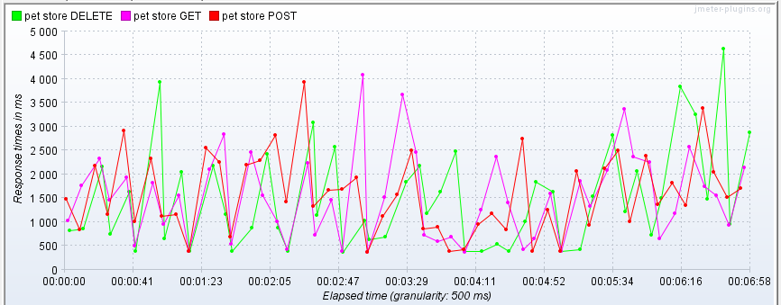

Total throughput 21.5/min

Error rate 0%

Summary of the test results: Four iterations were carried out with the launch of tests. When the peak load was reached, the application server worked correctly, as there were no saturation points (500/502 errors).

The application works within the declared load range and no failures or degradation of the system were detected.